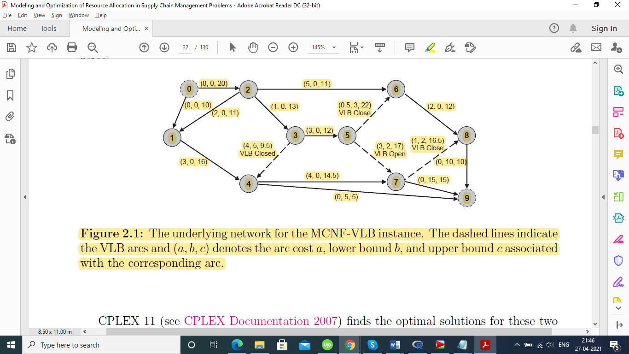

Kindly take only the color coded section into account while viewing the problem statement:

This is a network flow problem taken from a publicly available doctoral thesis work at UT Knoxville repository in an Industrial Engineering major. The problem area falls under data science. I have coded in R. We minimize costs of carrying from the supply node 0 to the demand code 9.

The arc is a triple (unit cost of flow, lower bound for the flow, upper bound for the flow).

Variable Lower Bound (VLB) arcs: If the flow falls below the lower bound, flow is set to zero by definition.

VLB Open and VLB Closed above indicate the final solution of the problem when solved analytically.

I on the other hand write a code to solve it using computer simulations.

**Note:**

The candidate solutions are difficult to reach: where Total Demand=Total Supply=30 and the demand at 3 individual nodes 4, 7, and 8 are 5, 15, and 10 respectively. I run 10 million simulations. Please feel free to edit.

Please review the code and let me know at the earliest – thanks for your time and effort.

Regards,

Prashant Prakash Deshpande